Figure 6
Connections over 200 kbps in at Least One Direction 2013-2017
(In thousands)

 | 2013 |  | 2014 |  | 2015 |  | 2016 |  | 2017
Technology | Jun | Dec | Jun* | Dec | Jun | Dec | Jun | Dec | Jun
Total | 284,692 | 293,397 | 324,471 | 338,202 | 357,613 | 375,895 | 395,603 | 404,960 | 408,816
Total Fixed | 93,986 | 96,032 | 95,982 | 98,245 | 100,179 | 102,216 | 104,087 | 105,704 | 106,254
Mobile Wireless | 190,706 | 197,365 | 228,489 | 239,957 | 257,434 | 273,679 | 291,516 | 299,256 | 302,562

Figure 7
Residential Connections over 200 kbps in at Least One Direction 2013-2017
(In thousands)

 | 2013 |  | 2014 |  | 2015 |  | 2016 |  | 2017
Technology | Jun | Dec | Jun* | Dec | Jun | Dec | Jun | Dec | Jun
Total | 235,273 | 246,797 | 277,551 | 290,696 | 306,292 | 322,557 | 341,537 | 349,597 | 353,057
Total Fixed | 85,277 | 87,599 | 87,345 | 89,530 | 91,439 | 93,434 | 95,001 | 96,597 | 97,071
Mobile Wireless | 149,996 | 159,197 | 190,205 | 201,166 | 214,853 | 229,122 | 246,537 | 253,000 | 255,986

* The June 2014 data have not been subjected to the typical quality checks (see Technical Notes).

The Commission approved changes to the Form 477 in June 2013 that affect the data beginning in June 2014 (see Technical Notes). Some previously-published
data may have been revised. Figures may not sum to totals elsewhere in this report due to rounding.

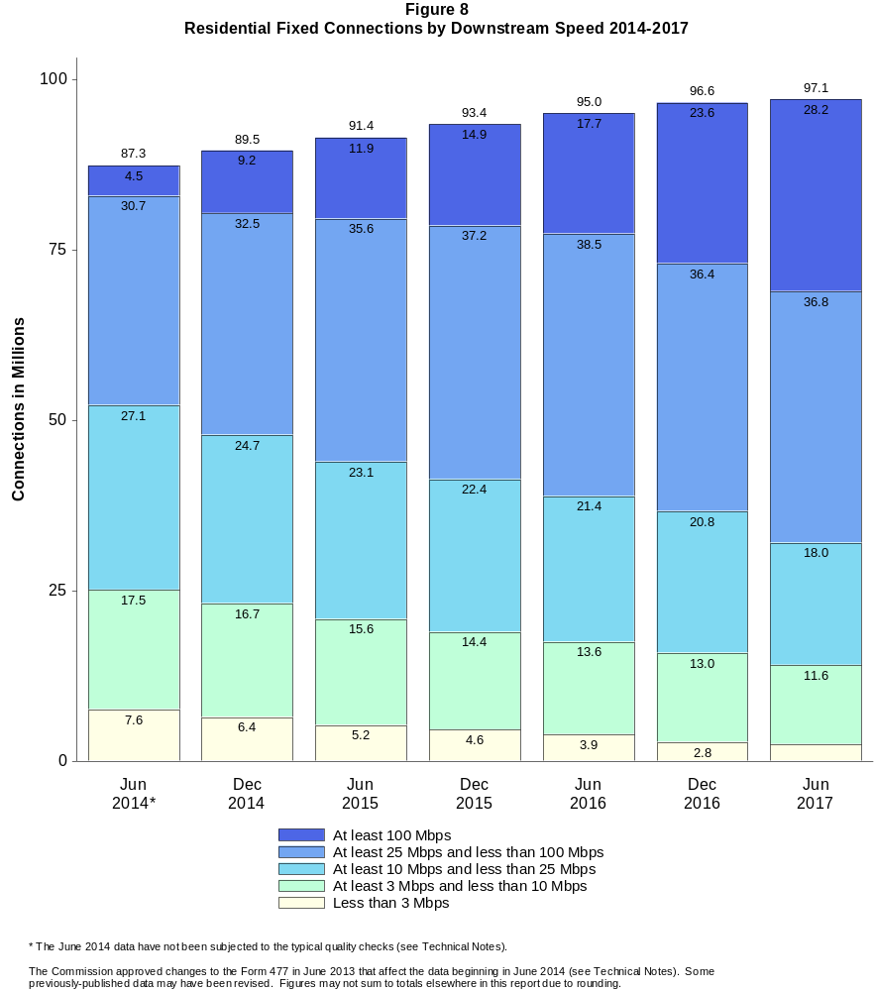

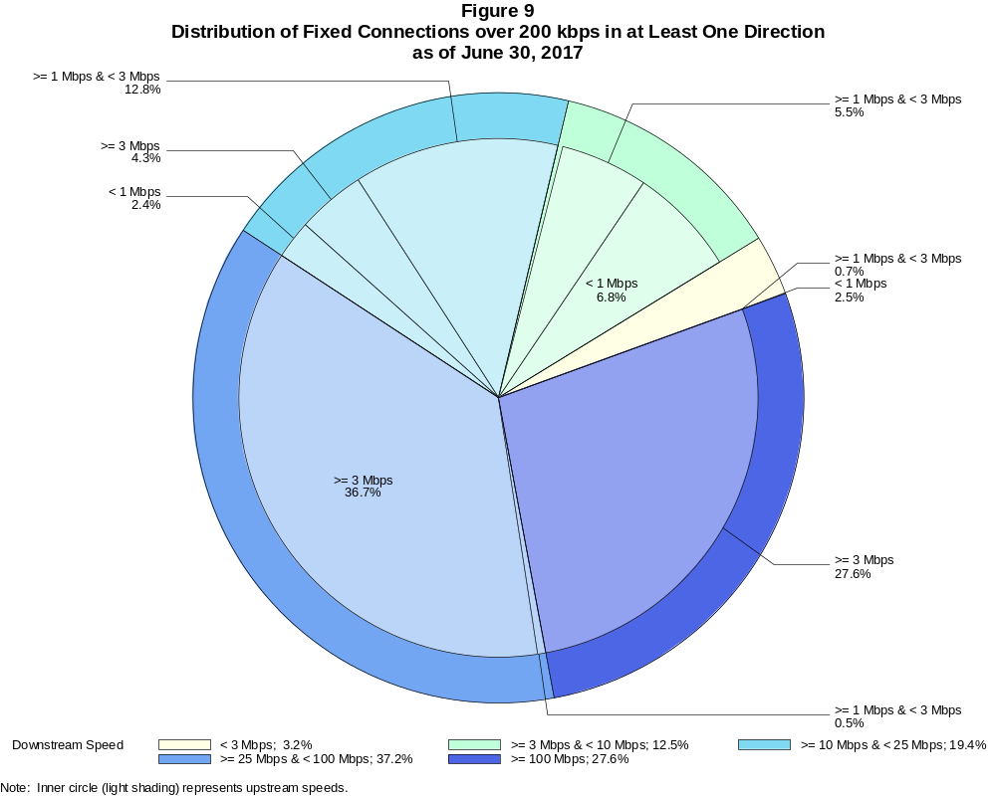

Fixed Connections over 200 kbps in at Least One Direction (in thousands)

 | Downstream Speed
Upstream Speed | Less than 3 Mbps | At least 3 Mbps  and less than 10 Mbps | At least 10 Mbps  and less than 25 Mbps | At least 25 Mbps  and less than 100 Mbps | At least 100 Mbps | Total
Less than 1 Mbps | 2,625 | 7,218 | 2,536 | # | # | 12,379
At least 1 Mbps & Less than 3 Mbps | 785 | 5,792 | 13,581 | 538 | 6 | 20,702
At least 3 Mbps | 9 | 322 | 4,528 | 38,958 | 29,356 | 73,173
Total | 3,418 | 13,332 | 20,645 | 39,496 | 29,362 | 106,254

Percentages

Less than 1 Mbps | 2.5 | 6.8 | 2.4 | 0.0 | 0.0 | 11.7
At least 1 Mbps & Less than 3 Mbps | 0.7 | 5.5 | 12.8 | 0.5 | 0.0 | 19.5
At least 3 Mbps | 0.0 | 0.3 | 4.3 | 36.7 | 27.6 | 68.9
Total | 3.2 | 12.5 | 19.4 | 37.2 | 27.6 | 100.0

Note: Figures may not sum to totals due to rounding. # = Rounds to zero.
Source: FCC Form 477.

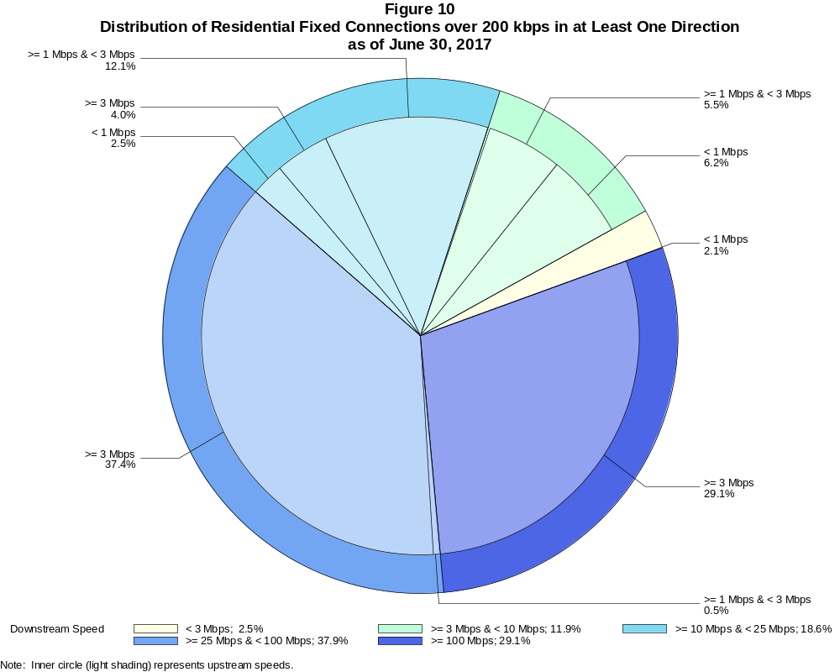

Residential Fixed Connections over 200 kbps in at Least One Direction (in thousands)

 | Downstream Speed
Upstream Speed | Less than 3 Mbps | At least 3 Mbps  and less than 10 Mbps | At least 10 Mbps  and less than 25 Mbps | At least 25 Mbps  and less than 100 Mbps | At least 100 Mbps | Total
Less than 1 Mbps | 2,052 | 6,045 | 2,379 | # | 0 | 10,476
At least 1 Mbps & Less than 3 Mbps | 382 | 5,381 | 11,772 | 494 | 5 | 18,034
At least 3 Mbps | 8 | 153 | 3,880 | 36,276 | 28,244 | 68,561
Total | 2,441 | 11,579 | 18,031 | 36,770 | 28,249 | 97,071

Percentages

Less than 1 Mbps | 2.1 | 6.2 | 2.5 | 0.0 | 0.0 | 10.8
At least 1 Mbps & Less than 3 Mbps | 0.4 | 5.5 | 12.1 | 0.5 | 0.0 | 18.6
At least 3 Mbps | 0.0 | 0.2 | 4.0 | 37.4 | 29.1 | 70.6
Total | 2.5 | 11.9 | 18.6 | 37.9 | 29.1 | 100.0

Note: Figures may not sum to totals due to rounding. # = Rounds to zero.
Source: FCC Form 477.

Figure 11
Connections over 200 kbps in at Least One Direction by Technology 2013-2017
(In thousands)

 | 2013 |  | 2014 |  | 2015 |  | 2016 |  | 2017
Technology | Jun | Dec | Jun* | Dec | Jun | Dec | Jun | Dec | Jun
Total | 284,692 | 293,397 | 324,471 | 338,202 | 357,613 | 375,895 | 395,603 | 404,960 | 408,816
Total Fixed | 93,986 | 96,032 | 95,982 | 98,245 | 100,179 | 102,216 | 104,087 | 105,704 | 106,254
aDSL | 30,657 | 30,690 | 29,870 | 29,533 | 29,351 | 28,134 | 27,488 | 26,527 | 25,506
sDSL | 117 | 108 | 96 | 72 | 77 | 60 | 55 | 42 | 44
Other Wireline¹ | 769 | 772 | 792 | 773 | 706 | 694 | 674 | 655 | 668
Cable Modem | 52,760 | 54,009 | 54,011 | 55,785 | 57,244 | 59,706 | 61,456 | 63,325 | 64,059
FTTP² | 7,250 | 7,745 | 8,312 | 9,077 | 9,688 | 10,498 | 11,143 | 12,053 | 12,906
Satellite | 1,623 | 1,849 | 1,964 | 2,006 | 2,058 | 2,071 | 2,079 | 1,864 | 1,826
Fixed Wireless | 810 | 858 | 935 | 999 | 1,056 | 1,054 | 1,192 | 1,238 | 1,245
Mobile Wireless | 190,706 | 197,365 | 228,489 | 239,957 | 257,434 | 273,679 | 291,516 | 299,256 | 302,562

¹ Power Line and Other are summarized with Other Wireline to maintain firm confidentiality. See Technical Notes at the end of the report for a description of
Form 477 technology categories and other reporting requirements.
² Fiber to the premises.
* The June 2014 data have not been subjected to the typical quality checks (see Technical Notes).

The Commission approved changes to the Form 477 in June 2013 that affect the data beginning in June 2014 (see Technical Notes). Some previously-published
data may have been revised. Figures may not sum to totals due to rounding.

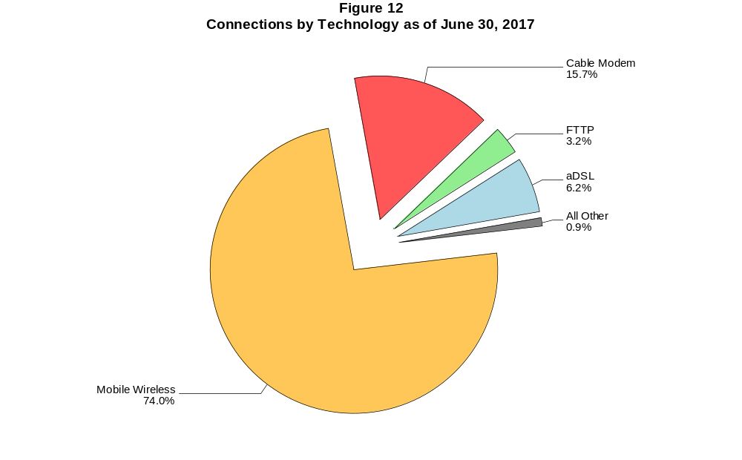

Figure 13
Residential Connections over 200 kbps in at Least One Direction by Technology 2013-2017
(In thousands)

 | 2013 |  | 2014 |  | 2015 |  | 2016 |  | 2017
Technology | Jun | Dec | Jun* | Dec | Jun | Dec | Jun | Dec | Jun
Total | 235,273 | 246,797 | 277,551 | 290,696 | 306,292 | 322,557 | 341,537 | 349,597 | 353,057
Total Fixed | 85,277 | 87,599 | 87,345 | 89,530 | 91,439 | 93,434 | 95,001 | 96,597 | 97,071
aDSL | 26,869 | 27,248 | 26,675 | 26,442 | 26,157 | 25,139 | 24,486 | 23,691 | 22,775
sDSL | 43 | 39 | 30 | 19 | 18 | 16 | 10 | 8 | 12
Other Wireline¹ | 22 | 22 | 57 | 59 | 59 | 54 | 51 | 32 | 74
Cable Modem | 49,494 | 50,709 | 50,389 | 52,061 | 53,544 | 55,799 | 57,358 | 59,145 | 59,687
FTTP² | 6,732 | 7,176 | 7,605 | 8,262 | 8,842 | 9,592 | 10,140 | 10,956 | 11,776
Satellite | 1,407 | 1,643 | 1,760 | 1,803 | 1,875 | 1,891 | 1,897 | 1,676 | 1,637
Fixed Wireless | 710 | 763 | 829 | 884 | 944 | 943 | 1,059 | 1,089 | 1,111
Mobile Wireless | 149,996 | 159,197 | 190,205 | 201,166 | 214,853 | 229,122 | 246,537 | 253,000 | 255,986

¹ Power Line and Other are summarized with Other Wireline to maintain firm confidentiality. See Technical Notes at the end of the report for a description of
Form 477 technology categories and other reporting requirements.
² Fiber to the premises.
* The June 2014 data have not been subjected to the typical quality checks (see Technical Notes).

The Commission approved changes to the Form 477 in June 2013 that affect the data beginning in June 2014 (see Technical Notes). Some previously-published
data may have been revised. Figures may not sum to totals due to rounding.

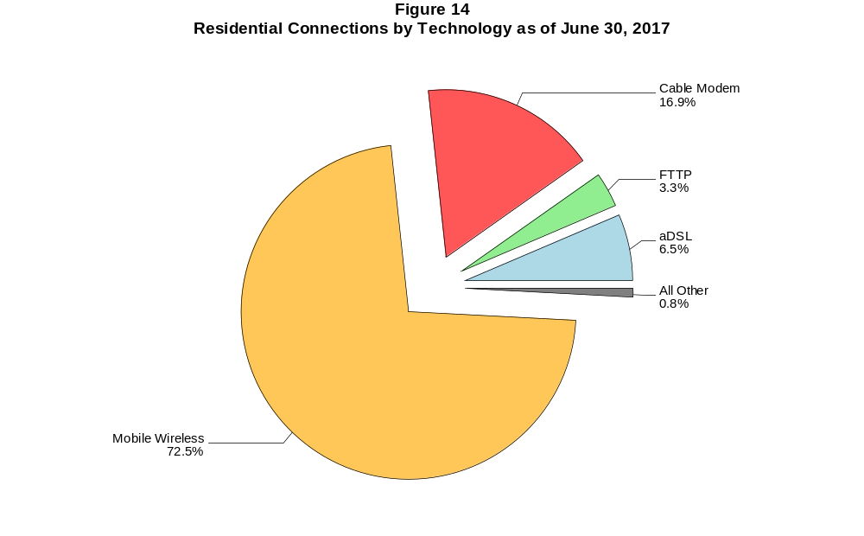

Figure 15
Fixed Connections at Least 3 Mbps Downstream and 768 kbps Upstream by Technology 2013-2017
(In thousands)

 | 2013 |  | 2014 |  | 2015 |  | 2016 |  | 2017
Technology | Jun | Dec | Jun* | Dec | Jun | Dec | Jun | Dec | Jun
Total | 68,673 | 78,175 | 78,981 | 83,872 | 89,011 | 92,356 | 95,516 | 98,750 | 100,098
aDSL | 14,233 | 18,540 | 17,246 | 18,557 | 20,947 | 20,744 | 21,147 | 21,042 | 20,621
sDSL | 34 | 36 | 33 | 28 | 24 | 20 | 20 | 20 | 24
Other Wireline¹ | 284 | 308 | 310 | 308 | 297 | 330 | 336 | 328 | 355
Cable Modem | 46,014 | 50,236 | 51,304 | 53,853 | 55,819 | 58,423 | 60,343 | 62,855 | 63,719
FTTP² | 6,981 | 7,486 | 8,111 | 8,974 | 9,552 | 10,383 | 11,030 | 11,953 | 12,813
Satellite | 791 | 1,181 | 1,424 | 1,558 | 1,690 | 1,744 | 1,775 | 1,609 | 1,586
Fixed Wireless | 337 | 388 | 553 | 594 | 681 | 712 | 865 | 943 | 981

¹ Power Line and Other are summarized with Other Wireline to maintain firm confidentiality. See Technical Notes at the end of the report for a description of Form
477 technology categories and other reporting requirements.
² Fiber to the premises.
* The June 2014 data have not been subjected to the typical quality checks (see Technical Notes).
# = Rounds to zero.

The Commission approved changes to the Form 477 in June 2013 that affect the data beginning in June 2014 (see Technical Notes). Some previously-published
data may have been revised. Figures may not sum to totals due to rounding.

Figure 16
Residential Fixed Connections at Least 3 Mbps Downstream and 768 kbps Upstream by Technology 2013-2017
(In thousands)

 | 2013 |  | 2014 |  | 2015 |  | 2016 |  | 2017
Technology | Jun | Dec | Jun* | Dec | Jun | Dec | Jun | Dec | Jun
Total | 63,342 | 72,476 | 73,042 | 77,540 | 82,320 | 85,439 | 88,197 | 91,248 | 92,354
aDSL | 12,666 | 16,715 | 15,673 | 16,867 | 18,988 | 18,866 | 19,207 | 19,133 | 18,719
sDSL | 13 | 13 | 7 | 2 | 1 | 2 | 2 | 3 | 7
Other Wireline¹ | 21 | 20 | 45 | 50 | 45 | 47 | 49 | 31 | 73
Cable Modem | 43,061 | 47,258 | 47,924 | 50,308 | 52,254 | 54,650 | 56,353 | 58,784 | 59,410
FTTP² | 6,504 | 6,958 | 7,491 | 8,246 | 8,750 | 9,512 | 10,063 | 10,883 | 11,704
Satellite | 788 | 1,177 | 1,419 | 1,552 | 1,682 | 1,734 | 1,764 | 1,596 | 1,571
Fixed Wireless | 289 | 335 | 483 | 516 | 599 | 628 | 759 | 820 | 870

¹ Power Line and Other are summarized with Other Wireline to maintain firm confidentiality. See Technical Notes at the end of the report for a description of Form
477 technology categories and other reporting requirements.
² Fiber to the premises.
* The June 2014 data have not been subjected to the typical quality checks (see Technical Notes).
# = Rounds to zero.

The Commission approved changes to the Form 477 in June 2013 that affect the data beginning in June 2014 (see Technical Notes). Some previously-published
data may have been revised. Figures may not sum to totals due to rounding.

Figure 17
Fixed Connections at Least 10 Mbps Downstream and 1 Mbps Upstream by Technology 2014-2017
(In thousands)

 | 2014 |  | 2015 |  | 2016 |  | 2017
Technology | Jun* | Dec | Jun | Dec | Jun | Dec | Jun
Total | 63,823 | 68,238 | 72,713 | 76,939 | 80,458 | 84,108 | 86,967
aDSL | 7,561 | 8,560 | 9,471 | 9,799 | 10,349 | 10,810 | 11,321
sDSL | 9 | 6 | 9 | 8 | 8 | 10 | 14
Other Wireline¹ | 169 | 186 | 182 | 203 | 210 | 217 | 253
Cable Modem | 47,296 | 49,837 | 52,658 | 55,710 | 57,951 | 60,349 | 61,704
FTTP² | 7,601 | 8,320 | 8,874 | 9,575 | 10,142 | 11,000 | 11,884
Satellite | 1,016 | 1,136 | 1,298 | 1,393 | 1,467 | 1,342 | 1,373
Fixed Wireless | 170 | 193 | 221 | 252 | 330 | 379 | 418

¹ Power Line and Other are summarized with Other Wireline to maintain firm confidentiality. See Technical Notes at the end of the report for a description of
Form 477 technology categories and other reporting requirements.
² Fiber to the premises.
* The June 2014 data have not been subjected to the typical quality checks (see Technical Notes).
# = Rounds to zero.

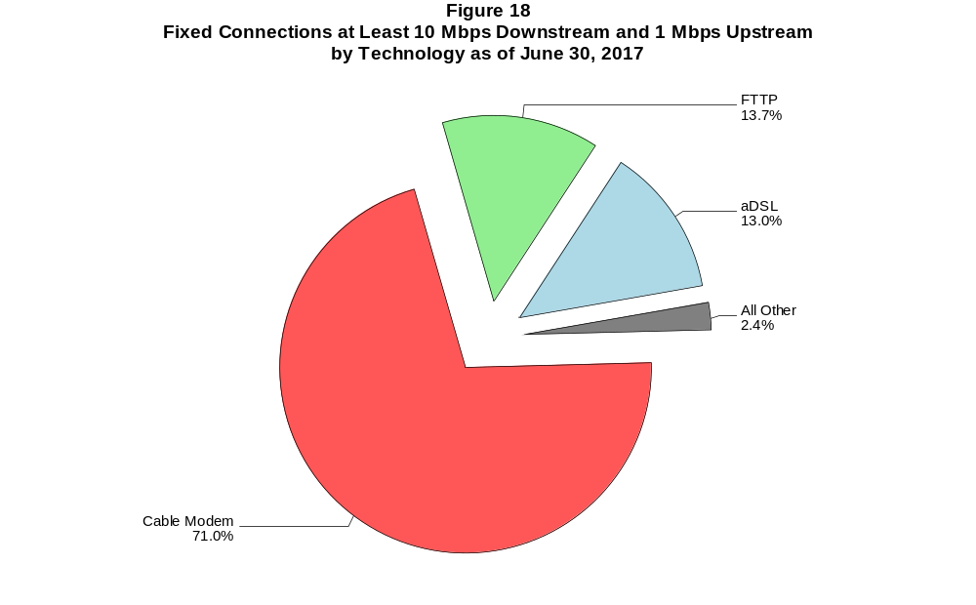

Figure 19
Residential Fixed Connections at Least 10 Mbps Downstream and 1 Mbps Upstream
by Technology 2014-2017
(In thousands)

 | 2014 |  | 2015 |  | 2016 |  | 2017
Technology | Jun* | Dec | Jun | Dec | Jun | Dec | Jun
Total | 59,729 | 63,732 | 67,898 | 71,784 | 74,840 | 78,197 | 80,671
aDSL | 7,025 | 7,970 | 8,743 | 9,069 | 9,526 | 9,963 | 10,415
sDSL | 3 | # | # | 1 | 2 | 2 | 6
Other Wireline¹ | 33 | 36 | 38 | 43 | 47 | 30 | 71
Cable Modem | 44,480 | 46,772 | 49,487 | 52,294 | 54,274 | 56,538 | 57,617
FTTP² | 7,032 | 7,653 | 8,144 | 8,776 | 9,248 | 10,004 | 10,835
Satellite | 1,014 | 1,133 | 1,293 | 1,386 | 1,460 | 1,333 | 1,362
Fixed Wireless | 142 | 167 | 191 | 213 | 283 | 327 | 365

¹ Power Line and Other are summarized with Other Wireline to maintain firm confidentiality. See Technical Notes at the end of the report for a description of
Form 477 technology categories and other reporting requirements.
² Fiber to the premises.
* The June 2014 data have not been subjected to the typical quality checks (see Technical Notes).
# = Rounds to zero.

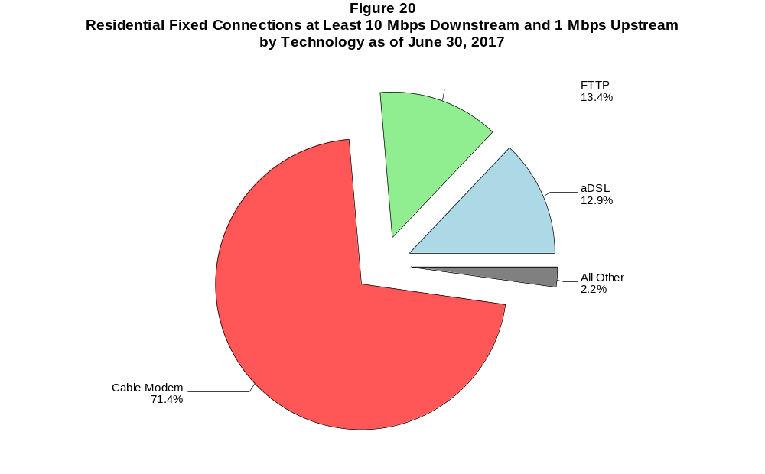

Figure 21
Fixed Connections at Least 25 Mbps Downstream and 3 Mbps Upstream by Technology 2014-2017
(In thousands)

 | 2014 |  | 2015 |  | 2016 |  | 2017
Technology | Jun+ | Dec | Jun | Dec | Jun | Dec | Jun
Total | 35,924 | 42,713 | 48,784 | 54,335 | 58,753 | 62,906 | 68,041
aDSL | 421 | 587 | 762 | 938 | 1,239 | 1,476 | 2,530
sDSL | 2 | 1 | 1 | * | * | * | *
Other Wireline¹ | 114 | 125 | 125 | 141 | 158 | 170 | 207
Cable Modem | 30,769 | 36,383 | 40,979 | 45,530 | 48,696 | 51,740 | 54,829
FTTP² | 4,600 | 5,589 | 6,871 | 7,691 | 8,608 | 9,449 | 10,374
Satellite | # | # | # | * | * | * | *
Fixed Wireless | 19 | 28 | 47 | 55 | 72 | 91 | 120

¹ Power Line and Other are summarized with Other Wireline to maintain firm confidentiality. See Technical Notes at the end of the report for a description of
Form 477 technology categories and other reporting requirements.
² Fiber to the premises.
+ The June 2014 data have not been subjected to the typical quality checks (see Technical Notes).
* = Data withheld to maintain firm confidentiality.
# = Rounds to zero.

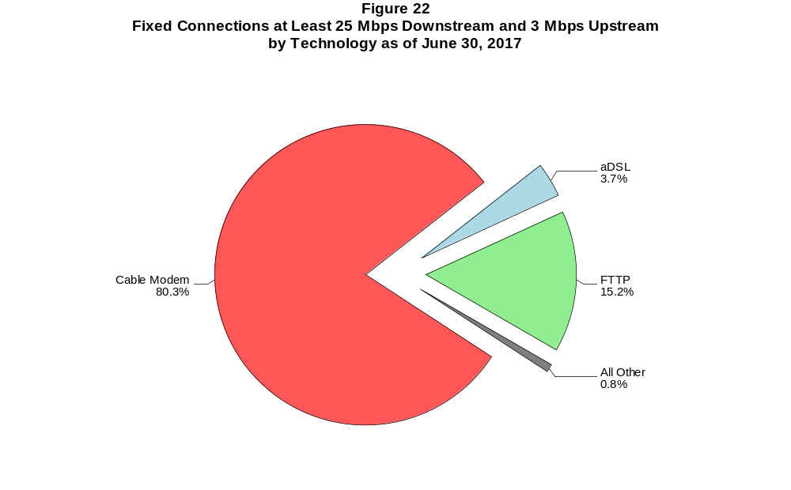

Figure 23
Residential Fixed Connections at Least 25 Mbps Downstream and 3 Mbps Upstream
by Technology 2014-2017
(In thousands)

 | 2014 |  | 2015 |  | 2016 |  | 2017
Technology | Jun+ | Dec | Jun | Dec | Jun | Dec | Jun
Total | 34,437 | 40,916 | 46,532 | 51,788 | 55,694 | 59,463 | 64,253
aDSL | 397 | 556 | 727 | 897 | 1,173 | 1,408 | 2,418
sDSL | # | # | # | * | * | * | *
Other Wireline¹ | 22 | 26 | 26 | 31 | 41 | 27 | 67
Cable Modem | 29,806 | 35,202 | 39,416 | 43,746 | 46,527 | 49,300 | 52,154
FTTP² | 4,198 | 5,111 | 6,323 | 7,089 | 7,916 | 8,674 | 9,532
Satellite | 0 | 0 | 0 | * | * | * | *
Fixed Wireless | 14 | 22 | 40 | 46 | 57 | 75 | 101

¹ Power Line and Other are summarized with Other Wireline to maintain firm confidentiality. See Technical Notes at the end of the report for a description of
Form 477 technology categories and other reporting requirements.
² Fiber to the premises.
+ The June 2014 data have not been subjected to the typical quality checks (see Technical Notes).
* = Data withheld to maintain firm confidentiality.
# = Rounds to zero.

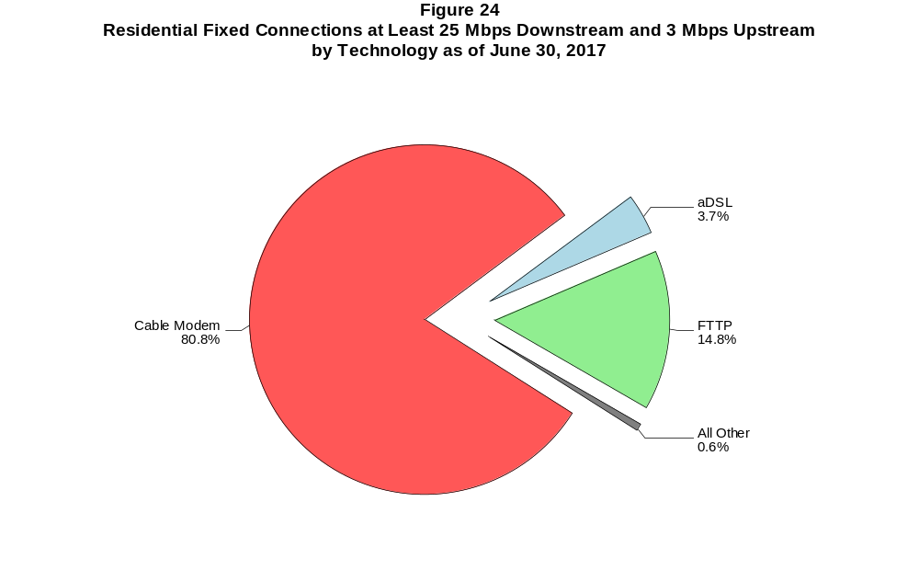

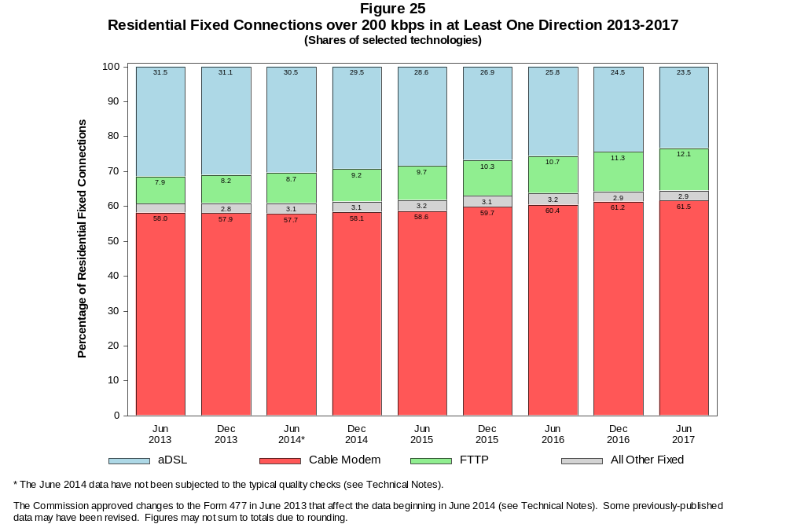

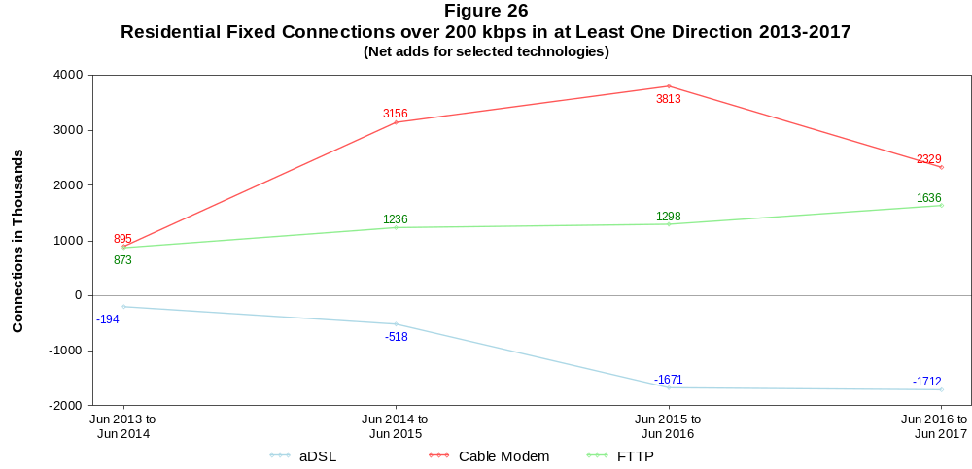

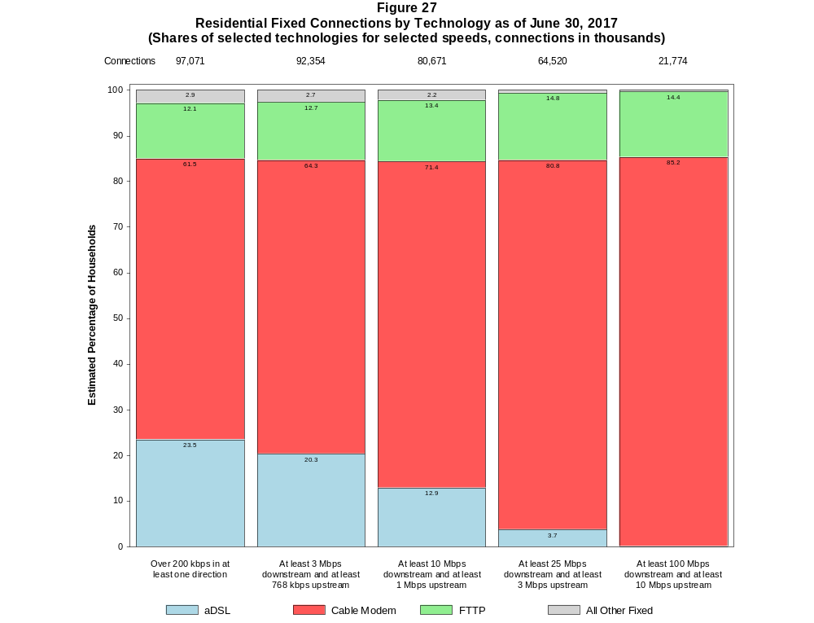

Figure 28
Fixed Connections by Downstream Speed Tier and Technology as of June 30, 2017
(In thousands)

 | Downstream Speed
Technology | Less than  1.5 Mbps | At least 1.5 Mbps  and less than  3 Mbps | At least 3 Mbps  and less than  10 Mbps | At least 10 Mbps  and less than  25 Mbps | At least 25 Mbps  and less than  100 Mbps | At least 100 Mbps | Total
aDSL | 856 | 1,569 | 9,622 | 10,571 | 2,870 | 18 | 25,506
sDSL | 12 | 8 | 10 | 10 | * | * | 44
Other Wireline¹ | 47 | 263 | 105 | 46 | 32 | 175 | 668
Cable Modem | 67 | 79 | 2,148 | 6,793 | 29,314 | 25,659 | 64,059
FTTP | 27 | 36 | 622 | 1,807 | 6,934 | 3,479 | 12,906
Satellite | 205 | 32 | 216 | 1,124 | * | * | 1,826
Fixed Wireless | 78 | 140 | 608 | 295 | 94 | 29 | 1,245
Total | 1,292 | 2,127 | 13,332 | 20,645 | 39,496 | 29,362 | 106,254

Percentages

aDSL | 0.8 | 1.5 | 9.1 | 9.9 | 2.7 | 0.0 | 24.0
sDSL | 0.0 | 0.0 | 0.0 | 0.0 | * | * | 0.0
Other Wireline¹ | 0.0 | 0.2 | 0.1 | 0.0 | 0.0 | 0.2 | 0.6
Cable Modem | 0.1 | 0.1 | 2.0 | 6.4 | 27.6 | 24.1 | 60.3
FTTP | 0.0 | 0.0 | 0.6 | 1.7 | 6.5 | 3.3 | 12.1
Satellite | 0.2 | 0.0 | 0.2 | 1.1 | * | * | 1.7
Fixed Wireless | 0.1 | 0.1 | 0.6 | 0.3 | 0.1 | 0.0 | 1.2
Total | 1.2 | 2.0 | 12.5 | 19.4 | 37.2 | 27.6 | 100.0

¹ Power Line and Other are summarized with Other Wireline to maintain firm confidentiality. See Technical Notes at the end of the report for a description of Form 477 technology categories
and other reporting requirements.
# = Rounds to Zero.
* = Data withheld to maintain firm confidentiality.
Note: Figures may not sum to totals due to rounding.
Source: FCC Form 477.

Figure 29
Residential Fixed Connections by Downstream Speed Tier and Technology as of June 30, 2017
(In thousands)

 | Downstream Speed
Technology | Less than  1.5 Mbps | At least 1.5 Mbps  and less than  3 Mbps | At least 3 Mbps  and less than  10 Mbps | At least 10 Mbps  and less than  25 Mbps | At least 25 Mbps  and less than  100 Mbps | At least 100 Mbps | Total
aDSL | 755 | 1,268 | 8,347 | 9,654 | 2,733 | 17 | 22,775
sDSL | 4 | 1 | 1 | 4 | * | * | 12
Other Wireline¹ | # | 1 | 2 | 3 | 6 | 61 | 74
Cable Modem | 60 | 45 | 1,905 | 5,392 | 27,275 | 25,009 | 59,687
FTTP | 17 | 27 | 565 | 1,600 | 6,426 | 3,141 | 11,776
Satellite | 54 | 9 | 211 | 1,116 | * | * | 1,637
Fixed Wireless | 70 | 128 | 548 | 262 | 82 | 22 | 1,111
Total | 961 | 1,480 | 11,579 | 18,031 | 36,770 | 28,249 | 97,071

Percentages

aDSL | 0.8 | 1.3 | 8.6 | 9.9 | 2.8 | 0.0 | 23.5
sDSL | 0.0 | 0.0 | 0.0 | 0.0 | * | * | 0.0
Other Wireline¹ | 0.0 | 0.0 | 0.0 | 0.0 | 0.0 | 0.1 | 0.1
Cable Modem | 0.1 | 0.0 | 2.0 | 5.6 | 28.1 | 25.8 | 61.5
FTTP | 0.0 | 0.0 | 0.6 | 1.6 | 6.6 | 3.2 | 12.1
Satellite | 0.1 | 0.0 | 0.2 | 1.1 | * | * | 1.7
Fixed Wireless | 0.1 | 0.1 | 0.6 | 0.3 | 0.1 | 0.0 | 1.1
Total | 1.0 | 1.5 | 11.9 | 18.6 | 37.9 | 29.1 | 100.0

¹ Power Line and Other are summarized with Other Wireline to maintain firm confidentiality. See Technical Notes at the end of the report for a description of Form 477 technology categories
and other reporting requirements.
# = Rounds to Zero.
* = Data withheld to maintain firm confidentiality.
Note: Figures may not sum to totals due to rounding.
Source: FCC Form 477.

Figure 30
Nationwide Number of Providers of Connections over 200 kbps in at Least One Direction
by Technology 2013-2017

 | 2013 |  | 2014 |  | 2015 |  | 2016 |  | 2017
Technology | Jun | Dec | Jun+ | Dec | Jun | Dec | Jun | Dec | Jun
aDSL | 852 | 851 | 793 | 793 | 792 | 778 | 769 | 774 | 769
sDSL | 246 | 239 | 192 | 187 | 177 | 180 | 172 | 161 | 162
Other Wireline¹ | 246 | 245 | 270 | 245 | 240 | 250 | 244 | 236 | 243
Cable Modem | 403 | 407 | 394 | 402 | 393 | 392 | 388 | 385 | 383
FTTP | 692 | 744 | 879 | 910 | 931 | 990 | 1,016 | 1,067 | 1,103
Satellite | 5 | 5 | 16 | 14 | 10 | 10 | 6 | 6 | 5
Fixed Wireless | 771 | 825 | 872 | 923 | 949 | 983 | 1,026 | 1,069 | 1,094
Mobile Wireless | 79 | 77 | 91 | 98 | 100 | 96 | 99 | 97 | 97
Power Line and Other¹ | 0 | * | - | - | - | - | - | - | -
Total | 1,714 | 1,773 | 1,816 | 1,873 | 1,882 | 1,918 | 1,956 | 2,000 | 2,029

¹ For this Figure, the categories Power Line and All Other were combined with Other Wireline from June 2014 forward.
+ The June 2014 data have not been subjected to the typical quality checks (see Technical Notes).
Multiple Form 477 filers within a holding company structure count as one provider. * = 1-3 providers.

The Commission approved changes to the Form 477 in June 2013 that affect the data beginning in June 2014 (see Technical Notes). Some previously-published
data may have been revised.

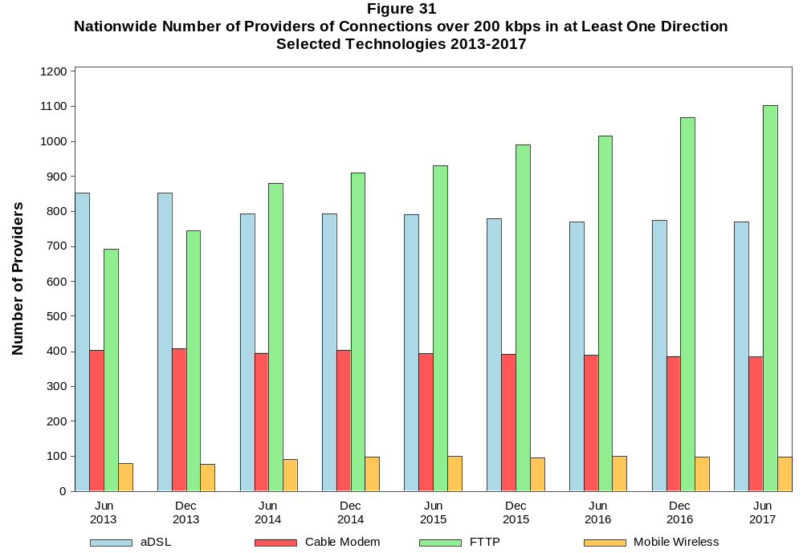

Figure 32
Residential Fixed Connections and Households by State as of June 30, 2017
(Connections and households, in thousands)

 |  | At least 200 kbps in  at least One Direction |  | At least 10 Mbps Down  and 1 Mbps Up |  | At least 25 Mbps Down  and 3 Mbps Up |  | At least 100 Mbps Down  and 10 Mbps Up
State | Households | Connections | Subscribership  Ratio | Connections | Subscribership  Ratio | Connections | Subscribership  Ratio | Connections | Subscribership  Ratio
Alabama | 1,851 | 1,305 | 0.70 | 1,003 | 0.54 | 719 | 0.39 | 82 | 0.04
Alaska | 250 | 207 | 0.83 | 154 | 0.61 | * | * | * | *
American Samoa | 10 | * | * | 0 | 0.00 | 0 | 0.00 | 0 | 0.00
Arizona | 2,449 | 2,034 | 0.83 | 1,552 | 0.63 | 1,283 | 0.52 | 435 | 0.18
Arkansas | 1,141 | 746 | 0.65 | 522 | 0.46 | 315 | 0.28 | 65 | 0.06
California | 12,807 | 11,109 | 0.87 | 9,651 | 0.75 | 7,674 | 0.60 | 3,542 | 0.28
Colorado | 2,052 | 1,826 | 0.89 | 1,402 | 0.68 | 1,288 | 0.63 | 491 | 0.24
Connecticut | 1,355 | 1,195 | 0.88 | 1,058 | 0.78 | 860 | 0.63 | 311 | 0.23
Delaware | 348 | 326 | 0.94 | 308 | 0.88 | 296 | 0.85 | 104 | 0.30
District of Columbia | 277 | 238 | 0.86 | 217 | 0.78 | 206 | 0.75 | * | *
Florida | 7,393 | 6,874 | 0.93 | 6,042 | 0.82 | 4,861 | 0.66 | 1,454 | 0.20
Georgia | 3,612 | 2,935 | 0.81 | 2,397 | 0.66 | 1,791 | 0.50 | 372 | 0.10
Guam | 42 | * | * | * | * | * | * | 0 | 0.00
Hawaii | 452 | 405 | 0.90 | 400 | 0.89 | * | * | * | *
Idaho | 596 | 483 | 0.81 | 276 | 0.46 | 213 | 0.36 | 18 | 0.03
Illinois | 4,802 | 3,751 | 0.78 | 3,184 | 0.66 | 2,448 | 0.51 | 495 | 0.10
Indiana | 2,514 | 1,878 | 0.75 | 1,473 | 0.59 | 1,069 | 0.43 | 234 | 0.09
Iowa | 1,243 | 933 | 0.75 | 627 | 0.50 | 503 | 0.40 | 133 | 0.11
Kansas | 1,116 | 874 | 0.78 | 668 | 0.60 | 448 | 0.40 | 200 | 0.18
Kentucky | 1,718 | 1,235 | 0.72 | 884 | 0.51 | 560 | 0.33 | 211 | 0.12
Louisiana | 1,731 | 1,234 | 0.71 | 988 | 0.57 | 684 | 0.39 | 172 | 0.10
Maine | 551 | 484 | 0.88 | 354 | 0.64 | 203 | 0.37 | 13 | 0.02
Maryland | 2,177 | 1,901 | 0.87 | 1,761 | 0.81 | 1,644 | 0.76 | 572 | 0.26
Massachusetts | 2,559 | 2,314 | 0.90 | 2,154 | 0.84 | 2,067 | 0.81 | 746 | 0.29
Michigan | 3,860 | 2,990 | 0.77 | 2,537 | 0.66 | 1,989 | 0.52 | 230 | 0.06
Minnesota | 2,135 | 1,723 | 0.81 | 1,287 | 0.60 | 1,130 | 0.53 | 274 | 0.13
Mississippi | 1,099 | 659 | 0.60 | 474 | 0.43 | 274 | 0.25 | 36 | 0.03
Missouri | 2,372 | 1,772 | 0.75 | 1,320 | 0.56 | 944 | 0.40 | 264 | 0.11
Montana | 413 | 329 | 0.80 | 222 | 0.54 | 191 | 0.46 | 11 | 0.03
Nebraska | 742 | 581 | 0.78 | 431 | 0.58 | 319 | 0.43 | 61 | 0.08

Figure 32 - Continued
Residential Fixed Connections and Households by State as of June 30, 2017
(Connections and households, in thousands)

 |  | At least 200 kbps in  at least One Direction |  | At least 10 Mbps Down  and 1 Mbps Up |  | At least 25 Mbps Down  and 3 Mbps Up |  | At least 100 Mbps Down  and 10 Mbps Up
State | Households | Connections | Subscribership  Ratio | Connections | Subscribership  Ratio | Connections | Subscribership  Ratio | Connections | Subscribership  Ratio
Nevada | 1,031 | 891 | 0.86 | 740 | 0.72 | 580 | 0.56 | * | *
New Hampshire | 521 | 484 | 0.93 | 414 | 0.79 | 373 | 0.72 | 135 | 0.26
New Jersey | 3,195 | 2,945 | 0.92 | 2,792 | 0.87 | 2,696 | 0.84 | 1,076 | 0.34
New Mexico | 763 | 548 | 0.72 | 332 | 0.43 | 288 | 0.38 | 80 | 0.10
New York | 7,266 | 6,189 | 0.85 | 5,726 | 0.79 | 5,038 | 0.69 | 2,076 | 0.29
North Carolina | 3,815 | 3,062 | 0.80 | 2,369 | 0.62 | 1,981 | 0.52 | 1,108 | 0.29
North Dakota | 305 | 246 | 0.81 | 215 | 0.70 | 172 | 0.56 | 31 | 0.10
Northern Mariana Isl | 16 | * | * | * | * | * | * | 0 | 0.00
Ohio | 4,601 | 3,573 | 0.78 | 2,880 | 0.63 | 1,764 | 0.38 | 277 | 0.06
Oklahoma | 1,462 | 1,014 | 0.69 | 741 | 0.51 | 477 | 0.33 | 140 | 0.10
Oregon | 1,546 | 1,304 | 0.84 | 1,045 | 0.68 | 922 | 0.60 | 265 | 0.17
Pennsylvania | 4,962 | 4,031 | 0.81 | 3,397 | 0.68 | 3,010 | 0.61 | 1,155 | 0.23
Puerto Rico | 1,237 | * | * | * | * | * | * | * | *
Rhode Island | 410 | 363 | 0.88 | 349 | 0.85 | 314 | 0.76 | * | *
South Carolina | 1,839 | 1,436 | 0.78 | 1,181 | 0.64 | 731 | 0.40 | 100 | 0.05
South Dakota | 334 | 259 | 0.78 | 220 | 0.66 | 188 | 0.56 | 17 | 0.05
Tennessee | 2,522 | 1,865 | 0.74 | 1,576 | 0.62 | 1,207 | 0.48 | 292 | 0.12
Texas | 9,290 | 7,320 | 0.79 | 6,131 | 0.66 | 4,368 | 0.47 | 2,072 | 0.22
Utah | 918 | 792 | 0.86 | 601 | 0.65 | 525 | 0.57 | 214 | 0.23
Vermont | 257 | 242 | 0.94 | 171 | 0.67 | 135 | 0.53 | 53 | 0.21
Virgin Islands | 43 | 27 | 0.62 | * | * | * | * | * | *
Virginia | 3,090 | 2,534 | 0.82 | 2,204 | 0.71 | 1,967 | 0.64 | 708 | 0.23
Washington | 2,697 | 2,390 | 0.89 | 1,950 | 0.72 | 1,786 | 0.66 | 682 | 0.25
West Virginia | 739 | 530 | 0.72 | 373 | 0.50 | 296 | 0.40 | 72 | 0.10
Wisconsin | 2,310 | 1,820 | 0.79 | 1,435 | 0.62 | 950 | 0.41 | 27 | 0.01
Wyoming | 227 | 177 | 0.78 | 128 | 0.57 | 105 | 0.46 | 1 | 0.00
Total | 119,064 | 97,071 | 0.82 | 80,671 | 0.68 | 64,520 | 0.54 | 21,774 | 0.18

# = Rounds to Zero; * = Data withheld to maintain firm confidentiality.
Note: Figures may not sum to totals due to rounding.
Sources: FCC Form 477 (Connections); 2012-2016 5-year estimates; Census 2010.

Figure 33
Connections by Type of End User by State as of June 30, 2017
(Connections over 200 kbps in at least one direction, in thousands)

 | Connections |  | Percentages
State | Residential | Business | Residential | Business | Total
Alabama | 5,228 | 647 | 89.0 | 11.0 | 5,875
Alaska | 786 | 118 | 87.0 | 13.0 | 904
American Samoa | * | * | * | * | *
Arizona | 6,865 | 1,023 | 87.0 | 13.0 | 7,888
Arkansas | 3,010 | 425 | 87.6 | 12.4 | 3,435
California | 43,461 | 8,099 | 84.3 | 15.7 | 51,560
Colorado | 6,035 | 916 | 86.8 | 13.2 | 6,951
Connecticut | 4,019 | 691 | 85.3 | 14.7 | 4,710
Delaware | 1,047 | 153 | 87.3 | 12.7 | 1,200
District of Columbia | 941 | 480 | 66.2 | 33.8 | 1,421
Florida | 22,842 | 3,862 | 85.5 | 14.5 | 26,704
Georgia | 11,125 | 1,618 | 87.3 | 12.7 | 12,744
Guam | 179 | 40 | 81.5 | 18.5 | 219
Hawaii | 1,653 | 205 | 89.0 | 11.0 | 1,858
Idaho | 1,688 | 240 | 87.6 | 12.4 | 1,927
Illinois | 13,958 | 2,297 | 85.9 | 14.1 | 16,255
Indiana | 6,770 | 890 | 88.4 | 11.6 | 7,660
Iowa | 3,203 | 524 | 85.9 | 14.1 | 3,727
Kansas | 4,176 | 474 | 89.8 | 10.2 | 4,651
Kentucky | 4,873 | 569 | 89.5 | 10.5 | 5,442
Louisiana | 4,981 | 661 | 88.3 | 11.7 | 5,642
Maine | 1,497 | 207 | 87.9 | 12.1 | 1,704
Maryland | 6,796 | 1,027 | 86.9 | 13.1 | 7,823
Massachusetts | 8,054 | 1,258 | 86.5 | 13.5 | 9,313
Michigan | 10,562 | 1,701 | 86.1 | 13.9 | 12,263
Minnesota | 5,939 | 973 | 85.9 | 14.1 | 6,912
Mississippi | 3,029 | 318 | 90.5 | 9.5 | 3,347
Missouri | 6,322 | 990 | 86.5 | 13.5 | 7,312
Montana | 1,120 | 138 | 89.0 | 11.0 | 1,257
Nebraska | 1,905 | 356 | 84.3 | 15.7 | 2,261
Nevada | 3,200 | 400 | 88.9 | 11.1 | 3,600
New Hampshire | 1,468 | 213 | 87.3 | 12.7 | 1,682
New Jersey | 10,223 | 1,762 | 85.3 | 14.7 | 11,985
New Mexico | 2,031 | 257 | 88.8 | 11.2 | 2,287
New York | 23,058 | 3,745 | 86.0 | 14.0 | 26,803
North Carolina | 10,447 | 1,570 | 86.9 | 13.1 | 12,017
North Dakota | 823 | 130 | 86.4 | 13.6 | 953
Northern Mariana Isl | * | * | * | * | *
Ohio | 12,504 | 1,782 | 87.5 | 12.5 | 14,286
Oklahoma | 3,872 | 565 | 87.3 | 12.7 | 4,437
Oregon | 4,445 | 671 | 86.9 | 13.1 | 5,116
Pennsylvania | 13,973 | 2,015 | 87.4 | 12.6 | 15,989
Puerto Rico | 3,392 | 263 | 92.8 | 7.2 | 3,655
Rhode Island | 1,108 | 176 | 86.3 | 13.7 | 1,283
South Carolina | 5,045 | 656 | 88.5 | 11.5 | 5,701
South Dakota | 915 | 110 | 89.3 | 10.7 | 1,025
Tennessee | 6,987 | 1,021 | 87.3 | 12.7 | 8,008
Texas | 28,736 | 4,948 | 85.3 | 14.7 | 33,684
Utah | 2,871 | 464 | 86.1 | 13.9 | 3,335
Vermont | 705 | 125 | 85.0 | 15.0 | 830
Virgin Islands | 105 | 12 | 90.0 | 10.0 | 117
Virginia | 8,604 | 1,499 | 85.2 | 14.8 | 10,103
Washington | 8,189 | 1,225 | 87.0 | 13.0 | 9,414
West Virginia | 1,654 | 186 | 89.9 | 10.1 | 1,841
Wisconsin | 5,877 | 963 | 85.9 | 14.1 | 6,840
Wyoming | 662 | 77 | 89.6 | 10.4 | 739
Total | 353,057 | 55,758 | 86.4 | 13.6 | 408,816

# = Rounds to Zero.
* = Data withheld to maintain firm confidentiality.
Figures may not sum to totals due to rounding.
Source: FCC Form 477.

Figure 34
Connections by Technology by State as of June 30, 2017
(Connections over 200 kbps in at least one direction, in thousands)

State | ADSL | SDSL | Other  Wireline¹ | Cable  Modem | Fiber | Satellite | Fixed  Wireless | Mobile  Wireless | Total
Alabama | 517 | # | * | 726 | 124 | * | 6 | 4,432 | 5,875
Alaska | 79 | # | 2 | * | 5 | * | 11 | 662 | 904
American Samoa | * | * | 0 | * | * | 0 | * | * | *
Arizona | 554 | # | * | 1,418 | 146 | * | 35 | 5,693 | 7,888
Arkansas | 351 | # | * | 387 | 25 | * | 7 | 2,614 | 3,435
California | 3,337 | 7 | * | 7,621 | 897 | * | 92 | 39,372 | 51,560
Colorado | * | 1 | 19 | 1,201 | 221 | * | 57 | 4,957 | 6,951
Connecticut | * | # | 4 | 963 | 10 | * | # | 3,397 | 4,710
Delaware | * | * | 3 | 218 | * | * | * | 846 | 1,200
District of Columbia | 32 | * | 7 | * | 57 | * | * | 1,145 | 1,421
Florida | 1,665 | # | * | 4,941 | 762 | * | 11 | 19,195 | 26,704
Georgia | 1,031 | # | * | 1,805 | 304 | * | 3 | 9,515 | 12,744
Guam | * | 0 | * | * | * | 0 | 0 | 179 | 219
Hawaii | * | * | 1 | * | 31 | * | 2 | 1,417 | 1,858
Idaho | 175 | # | * | 209 | 79 | * | 50 | 1,399 | 1,927
Illinois | 1,225 | 1 | * | 2,602 | 125 | * | 73 | 12,154 | 16,255
Indiana | 681 | # | * | 1,076 | 188 | * | 41 | 5,619 | 7,660
Iowa | 295 | 1 | * | 474 | 177 | * | 42 | 2,707 | 3,727
Kansas | 252 | # | * | 472 | 168 | * | 40 | 3,696 | 4,651
Kentucky | 442 | # | * | 719 | 116 | * | 19 | 4,105 | 5,442
Louisiana | 423 | # | * | 788 | 84 | * | 6 | 4,278 | 5,642
Maine | 130 | 1 | * | 369 | 10 | * | 6 | 1,173 | 1,704
Maryland | * | # | 16 | 1,076 | * | * | 5 | 5,755 | 7,823
Massachusetts | * | # | 21 | 1,852 | * | * | 3 | 6,774 | 9,313
Michigan | 870 | 3 | * | 2,192 | 42 | * | 48 | 9,008 | 12,263
Minnesota | 509 | 3 | * | 1,088 | 208 | * | 29 | 5,035 | 6,912
Mississippi | 339 | * | 3 | 312 | 26 | * | 2 | 2,610 | 3,347
Missouri | 711 | # | * | 888 | 210 | * | 40 | 5,383 | 7,312
Montana | 106 | # | * | 199 | 26 | * | 23 | 889 | 1,257
Nebraska | 153 | # | * | 393 | 58 | * | 25 | 1,624 | 2,261

Figure 34 - Continued
Connections by Technology by State as of June 30, 2017
(Connections over 200 kbps in at least one direction, in thousands)

State | ADSL | SDSL | Other  Wireline¹ | Cable  Modem | Fiber | Satellite | Fixed  Wireless | Mobile  Wireless | Total
Nevada | 233 | # | 6 | * | 18 | * | 16 | 2,626 | 3,600
New Hampshire | 79 | # | * | 422 | 27 | * | # | 1,143 | 1,682
New Jersey | 184 | # | 27 | 2,072 | * | * | 1 | 8,733 | 11,985
New Mexico | 243 | # | * | 281 | 39 | * | 22 | 1,686 | 2,287
New York | 459 | 2 | 38 | 4,699 | * | * | 5 | 19,982 | 26,803
North Carolina | 904 | 1 | * | 2,074 | 266 | * | 7 | 8,689 | 12,017
North Dakota | 46 | # | * | 144 | 80 | * | 5 | 675 | 953
Northern Mariana Isl | * | 0 | 0 | * | * | 0 | 0 | * | *
Ohio | 1,122 | # | * | 2,406 | 203 | * | 42 | 10,450 | 14,286
Oklahoma | 381 | # | * | 577 | 57 | * | 48 | 3,321 | 4,437
Oregon | 265 | # | * | 915 | 182 | * | 24 | 3,689 | 5,116
Pennsylvania | 638 | # | 27 | 2,768 | * | * | 8 | 11,575 | 15,989
Puerto Rico | * | 0 | * | * | 7 | * | 8 | 2,943 | 3,655
Rhode Island | * | * | 2 | * | * | * | * | 888 | 1,283
South Carolina | 467 | # | * | 921 | 125 | * | 2 | 4,143 | 5,701
South Dakota | 47 | * | # | 167 | 55 | * | 10 | 739 | 1,025
Tennessee | 557 | # | * | 1,152 | 262 | * | 11 | 5,958 | 8,008
Texas | 2,442 | 2 | * | 4,096 | 1,055 | * | 187 | 25,673 | 33,684
Utah | 175 | # | * | 473 | 156 | * | 50 | 2,471 | 3,335
Vermont | 120 | * | 3 | 141 | 22 | * | 1 | 537 | 830
Virgin Islands | * | 0 | * | * | * | * | * | * | 117
Virginia | 311 | # | * | 1,452 | 883 | * | 17 | 7,333 | 10,103
Washington | 457 | # | * | 1,792 | 238 | * | 30 | 6,821 | 9,414
West Virginia | * | * | 1 | 354 | 10 | * | 2 | 1,258 | 1,841
Wisconsin | 640 | 9 | 5 | * | 87 | * | 41 | 4,863 | 6,840
Wyoming | 52 | # | * | 108 | 10 | * | 21 | 540 | 739
Total | 25,506 | 44 | 668 | 64,059 | 12,906 | 1,826 | 1,245 | 302,562 | 408,816

¹ PowerLine and Other are summarized with Other Wireline to maintain firm confidentiality. See Technical Notes at the end of the report for a description of Form 477 technology categories and
other reporting requirements.
# = Rounds to Zero.
* = Data withheld to maintain firm confidentiality.
Figures may not sum to totals due to rounding.
Source: FCC Form 477.

Figure 35
Percentage of Fixed Connections by Downstream Speed by State as of June 30, 2017

 | Over 200 kbps Upstream and
State | % over 200 kbps  Downstream | % at least 3 Mbps  Downstream | % at least 10 Mbps  Downstream | % at least 25 Mbps  Downstream | % at least 100 Mbps  Downstream
Alabama | 99.4 | 94.2 | 78.6 | 53.8 | 11.1
Alaska | 98.0 | 90.1 | 74.2 | 53.5 | 39.4
American Samoa | * | * | * | * | *
Arizona | 99.8 | 96.9 | 85.8 | 62.3 | 24.6
Arkansas | 99.4 | 93.6 | 73.5 | 43.1 | 11.4
California | 99.7 | 97.5 | 85.0 | 66.4 | 38.1
Colorado | 99.8 | 95.7 | 87.5 | 68.6 | 43.1
Connecticut | 99.5 | 99.0 | 87.3 | 69.6 | 35.9
Delaware | 99.9 | 98.5 | 93.2 | 87.8 | 48.3
District of Columbia | 99.9 | 97.5 | 88.2 | 81.6 | 48.7
Florida | 99.6 | 97.7 | 89.9 | 69.4 | 20.6
Georgia | 99.3 | 96.2 | 81.9 | 59.9 | 13.4
Guam | * | * | * | * | *
Hawaii | 100.0 | 99.7 | 97.6 | 86.9 | 47.7
Idaho | 99.6 | 94.5 | 71.8 | 43.9 | 26.1
Illinois | 99.7 | 97.5 | 84.1 | 63.2 | 16.2
Indiana | 99.4 | 96.7 | 79.5 | 55.2 | 12.2
Iowa | 99.6 | 93.7 | 74.9 | 53.0 | 15.2
Kansas | 99.7 | 95.2 | 77.2 | 49.4 | 22.9
Kentucky | 99.1 | 94.6 | 72.1 | 45.0 | 16.6
Louisiana | 99.3 | 95.0 | 80.1 | 54.9 | 14.8
Maine | 99.0 | 95.1 | 72.0 | 40.7 | 2.6
Maryland | 99.8 | 98.1 | 91.1 | 83.9 | 42.3
Massachusetts | 99.9 | 98.4 | 91.9 | 84.6 | 49.1
Michigan | 99.4 | 97.2 | 84.1 | 64.4 | 8.3
Minnesota | 99.7 | 95.6 | 82.8 | 64.3 | 26.9
Mississippi | 99.1 | 92.6 | 72.6 | 42.6 | 14.5
Missouri | 99.5 | 94.8 | 78.6 | 53.2 | 37.8
Montana | 99.7 | 91.9 | 73.6 | 58.0 | 4.3
Nebraska | 99.7 | 96.5 | 77.6 | 54.1 | 11.5

Figure 35 - Continued
Percentage of Fixed Connections by Downstream Speed by State as of June 30, 2017

 | Over 200 kbps Upstream and
State | % over 200 kbps  Downstream | % at least 3 Mbps  Downstream | % at least 10 Mbps  Downstream | % at least 25 Mbps  Downstream | % at least 100 Mbps  Downstream
Nevada | 99.9 | 98.1 | 88.0 | 65.9 | 18.9
New Hampshire | 99.1 | 96.2 | 84.0 | 72.0 | 45.7
New Jersey | 99.8 | 98.5 | 94.0 | 89.3 | 45.4
New Mexico | 99.7 | 92.9 | 75.2 | 51.3 | 28.9
New York | 99.7 | 98.5 | 91.0 | 79.5 | 31.9
North Carolina | 99.3 | 96.3 | 81.0 | 63.0 | 34.4
North Dakota | 99.9 | 97.1 | 88.1 | 71.6 | 18.3
Northern Mariana Isl | * | * | * | * | *
Ohio | 99.8 | 97.1 | 80.6 | 48.3 | 8.5
Oklahoma | 99.6 | 96.6 | 73.3 | 46.4 | 16.7
Oregon | 99.8 | 96.1 | 85.7 | 68.8 | 35.2
Pennsylvania | 99.7 | 96.9 | 84.9 | 73.1 | 41.4
Puerto Rico | 100.0 | 83.3 | 52.3 | 29.6 | 1.0
Rhode Island | 99.6 | 98.8 | 94.5 | 84.5 | 30.9
South Carolina | 99.5 | 96.2 | 82.6 | 50.6 | 8.7
South Dakota | 99.7 | 97.1 | 86.4 | 72.2 | 7.5
Tennessee | 99.5 | 96.5 | 84.7 | 63.3 | 15.9
Texas | 99.8 | 97.4 | 83.3 | 58.1 | 31.9
Utah | 99.9 | 97.0 | 84.9 | 65.4 | 40.1
Vermont | 98.8 | 85.4 | 66.7 | 48.8 | 32.6
Virgin Islands | 100.0 | 81.6 | 46.3 | * | *
Virginia | 99.4 | 97.0 | 87.0 | 75.1 | 34.8
Washington | 99.6 | 96.5 | 86.8 | 72.0 | 47.4
West Virginia | 99.0 | 97.3 | 69.2 | 54.1 | 27.3
Wisconsin | 99.1 | 95.4 | 81.0 | 51.6 | 3.4
Wyoming | 99.7 | 93.1 | 78.1 | 58.7 | 1.3
Total | 99.6 | 96.8 | 84.2 | 64.8 | 27.6

Figure 36
Providers of Connections by Technology by State as of June 30, 2017
(Connections over 200 kbps in at least one direction, in thousands)

State | ADSL | SDSL | Other  Wireline¹ | Cable  Modem | Fiber | Satellite | Fixed  Wireless | Mobile  Wireless | Total
Alabama | 24 | 8 | * | 19 | 41 | * | 25 | 6 | 92
Alaska | 13 | 4 | 13 | * | 10 | * | 16 | 8 | 40
American Samoa | * | * | 0 | * | * | 0 | * | * | *
Arizona | 21 | 4 | * | 16 | 38 | * | 47 | 7 | 104
Arkansas | 25 | 6 | * | 17 | 35 | * | 22 | 5 | 79
California | 38 | 17 | * | 29 | 62 | * | 102 | 6 | 187
Colorado | * | 9 | 32 | 19 | 54 | * | 55 | 9 | 131
Connecticut | * | 7 | 20 | 10 | 23 | * | 4 | 4 | 42
Delaware | * | * | 14 | 6 | * | * | * | 4 | 29
District of Columbia | 8 | * | 18 | * | 24 | * | * | 4 | 39
Florida | 23 | 11 | * | 24 | 64 | * | 29 | 5 | 117
Georgia | 29 | 6 | * | 34 | 82 | * | 23 | 4 | 126
Guam | * | 0 | * | * | * | 0 | 0 | 4 | 4
Hawaii | * | * | 7 | * | 12 | * | 5 | 5 | 24
Idaho | 25 | 5 | * | 19 | 36 | * | 37 | 10 | 80
Illinois | 57 | 9 | * | 19 | 89 | * | 79 | 8 | 184
Indiana | 40 | 6 | * | 12 | 60 | * | 61 | 5 | 121
Iowa | 100 | 21 | * | 46 | 144 | * | 92 | 34 | 236
Kansas | 29 | 11 | * | 28 | 60 | * | 55 | 9 | 119
Kentucky | 21 | 6 | * | 30 | 46 | * | 31 | 7 | 104
Louisiana | 16 | 6 | * | 18 | 39 | * | 13 | 5 | 69
Maine | 17 | 7 | * | 9 | 24 | * | 9 | 5 | 43
Maryland | * | 8 | 25 | 16 | * | * | 18 | 5 | 74
Massachusetts | * | 6 | 27 | 11 | * | * | 19 | 5 | 71
Michigan | 34 | 10 | * | 25 | 60 | * | 43 | 6 | 125
Minnesota | 46 | 9 | * | 22 | 71 | * | 47 | 5 | 128
Mississippi | 18 | * | 23 | 16 | 22 | * | 12 | 5 | 63
Missouri | 40 | 11 | * | 19 | 57 | * | 70 | 8 | 148
Montana | 21 | 5 | * | 8 | 29 | * | 26 | 7 | 63
Nebraska | 30 | 4 | * | 20 | 50 | * | 38 | 9 | 92

Figure 36 - Continued
Providers of Connections by Technology by State as of June 30, 2017
(Connections over 200 kbps in at least one direction, in thousands)

State | ADSL | SDSL | Other  Wireline¹ | Cable  Modem | Fiber | Satellite | Fixed  Wireless | Mobile  Wireless | Total
Nevada | 17 | 7 | 26 | * | 30 | * | 22 | 7 | 70
New Hampshire | 13 | 8 | * | 6 | 23 | * | 5 | 6 | 42
New Jersey | 16 | 8 | 36 | 12 | * | * | 11 | 4 | 70
New Mexico | 21 | 7 | * | 10 | 27 | * | 27 | 8 | 71
New York | 38 | 10 | 35 | 21 | * | * | 31 | 7 | 113
North Carolina | 26 | 8 | * | 24 | 55 | * | 22 | 6 | 101
North Dakota | 24 | 9 | * | 8 | 30 | * | 15 | 6 | 48
Northern Mariana Isl | * | 0 | 0 | * | * | 0 | 0 | * | *
Ohio | 37 | 6 | * | 31 | 64 | * | 55 | 4 | 141
Oklahoma | 39 | 9 | * | 12 | 49 | * | 45 | 12 | 110
Oregon | 42 | 10 | * | 18 | 55 | * | 46 | 6 | 110
Pennsylvania | 30 | 8 | 31 | 27 | * | * | 28 | 8 | 115
Puerto Rico | * | 0 | * | * | 7 | * | 7 | 5 | 16
Rhode Island | * | * | 11 | * | * | * | * | 4 | 25
South Carolina | 19 | 4 | * | 16 | 32 | * | 9 | 6 | 55
South Dakota | 23 | * | 12 | 6 | 34 | * | 20 | 8 | 70
Tennessee | 23 | 7 | * | 23 | 45 | * | 31 | 7 | 102
Texas | 67 | 19 | * | 38 | 110 | * | 138 | 9 | 246
Utah | 20 | 4 | * | 12 | 28 | * | 27 | 9 | 72
Vermont | 11 | * | 12 | 5 | 19 | * | 4 | 6 | 34
Virgin Islands | * | 0 | * | * | * | * | * | * | 8
Virginia | 27 | 11 | * | 19 | 60 | * | 34 | 6 | 111
Washington | 26 | 8 | * | 24 | 56 | * | 58 | 6 | 122
West Virginia | * | * | 14 | 17 | 19 | * | 14 | 6 | 56
Wisconsin | 48 | 9 | 30 | * | 64 | * | 46 | 6 | 129
Wyoming | 16 | 5 | * | 6 | 18 | * | 27 | 8 | 52
Total | 769 | 162 | 243 | 383 | 1,103 | 5 | 1,094 | 97 | 2,029

¹ Power Line and Other are summarized with Other Wireline. See Technical Notes at the end of the report for a description of Form 477 technology categories and other reporting requirements.
# = Rounds to Zero.
* = Data withheld to maintain firm confidentiality.
Figures may not sum to totals due to rounding.
Source: FCC Form 477.

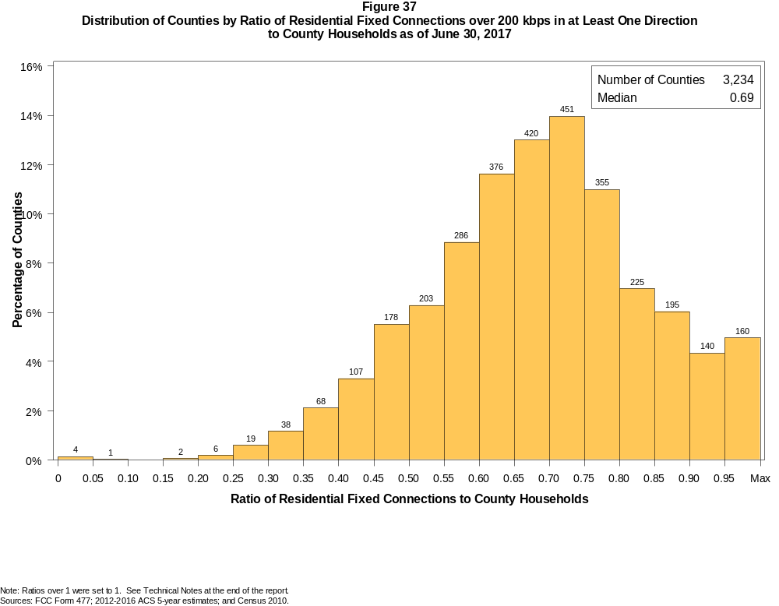

Figure 38
Distribution of Counties by Ratio of Residential Fixed Connections over 200 kbps in at Least One Direction
to County Households by Technology as of June 30, 2017

 | Ratio of Residential Fixed Connections to County Households
Technology | Zero | Greater than 0 and no more than 5% | Greater than 5 and no more than 10% | Greater than 10 and no more than 20% | Greater than 20 and no more than 30% | Greater than 30 and no more than 40% | Greater than 40 and no more than 50% | Greater than 50 and no more than 60% | Greater than 60 and no more than 80% | Greater than 80 and no more than 100% | 100% or more
aDSL | 1.1 | 5.6 | 6.2 | 26.4 | 29.8 | 17.3 | 8.5 | 3.0 | 1.6 | 0.2 | 0.2
sDSL | 89.6 | 10.1 | 0.2 | 0.1 | 0.0 | 0.0 | 0.0 | 0.0 | 0.0 | 0.0 | 0.0
Other Wireline | 91.6 | 8.3 | 0.1 | 0.0 | 0.0 | 0.0 | 0.0 | 0.0 | 0.0 | 0.0 | 0.0
Cable Modem | 13.2 | 7.0 | 6.2 | 13.8 | 13.7 | 14.3 | 11.6 | 10.9 | 7.8 | 1.1 | 0.3
FTTP | 22.8 | 47.8 | 8.1 | 8.8 | 4.2 | 2.8 | 2.2 | 1.4 | 1.7 | 0.1 | 0.0
Satellite | 1.3 | 67.1 | 21.7 | 8.9 | 0.8 | 0.1 | 0.0 | 0.0 | 0.0 | 0.1 | 0.0
Fixed Wireless | 27.0 | 52.4 | 10.7 | 7.0 | 1.9 | 0.6 | 0.3 | 0.0 | 0.0 | 0.0 | 0.1
Total | 0.1 | 0.0 | 0.0 | 0.1 | 0.8 | 3.3 | 8.8 | 15.1 | 49.5 | 19.2 | 3.1

¹ Power Line and Other are summarized with Other Wireline. See Technical Notes at the end of the report for a description of Form 477 technology categories and other reporting requirements.
Note: Figures may not sum to totals due to rounding.
Sources: FCC Form 477; 2012-2016 ACS 5-year estimates; and Census 2010.

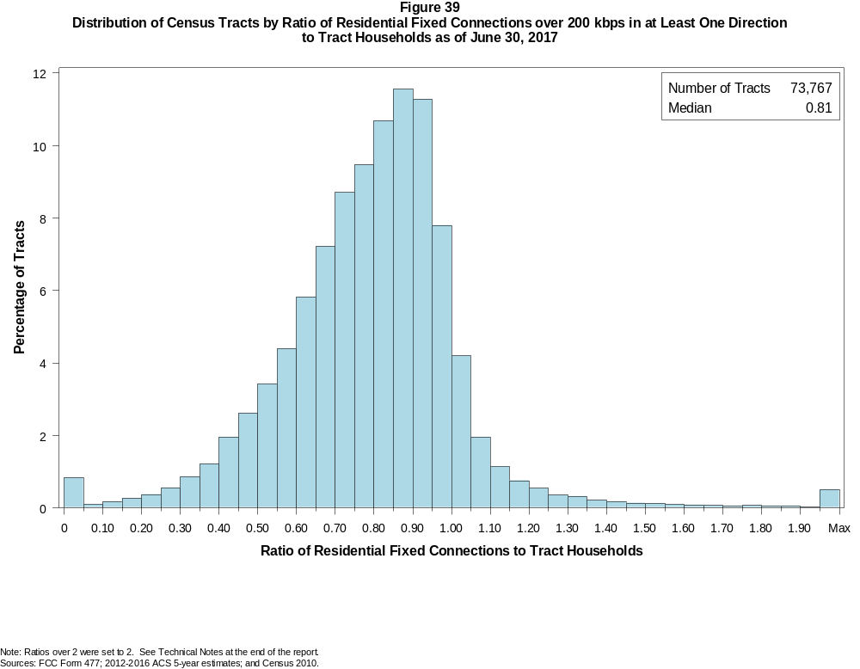

Figure 40
Distribution of Census Tracts by Ratio of Residential Fixed Connections over 200 kbps in at Least One Direction
to Tract Households by Technology as of June 30, 2017

 | Ratio of Residential Fixed Connections to Tract Households
Technology | Zero | Greater than 0 and no more than 5% | Greater than 5 and no more than 10% | Greater than 10 and no more than 20% | Greater than 20 and no more than 30% | Greater than 30 and no more than 40% | Greater than 40 and no more than 50% | Greater than 50 and no more than 60% | Greater than 60 and no more than 80% | Greater than 80 and no more than 100% | 100% or more
aDSL | 2.0 | 19.2 | 12.7 | 24.8 | 20.1 | 12.2 | 5.3 | 2.1 | 1.2 | 0.2 | 0.2
sDSL | 98.5 | 1.4 | 0.0 | 0.0 | 0.0 | 0.0 | 0.0 | 0.0 | 0.0 | 0.0 | 0.0
Other Wireline | 98.4 | 1.4 | 0.1 | 0.1 | 0.0 | 0.0 | 0.0 | 0.0 | 0.0 | 0.0 | 0.0
Cable Modem | 5.2 | 2.7 | 1.7 | 4.0 | 7.1 | 12.5 | 17.6 | 18.9 | 22.7 | 5.7 | 1.7
FTTP | 50.1 | 17.4 | 5.6 | 8.1 | 5.3 | 4.6 | 3.9 | 2.6 | 2.0 | 0.3 | 0.1
Satellite | 32.2 | 58.6 | 5.0 | 3.1 | 0.7 | 0.2 | 0.1 | 0.0 | 0.0 | 0.0 | 0.0
Fixed Wireless | 74.8 | 19.4 | 2.6 | 2.0 | 0.7 | 0.3 | 0.1 | 0.1 | 0.0 | 0.0 | 0.0
Total | 0.8 | 0.1 | 0.1 | 0.4 | 0.9 | 2.1 | 4.6 | 7.8 | 31.2 | 41.3 | 10.8

¹ Power Line and Other are summarized with Other Wireline. See Technical Notes at the end of the report for a description of Form 477 technology categories and other reporting requirements.
Note: Figures may not sum to totals due to rounding.
Sources: FCC Form 477; 2012-2016 ACS 5-year estimates; and Census 2010.

Figure 41
Percentage of Developed Census Blocks with Residential Fixed Service by Technology as of June 30, 2017
(Internet Access Service over 200 kbps in at least one direction)

 | Number of Providers
Technology | Zero | One | Two | Three | Four | Five | Six | Seven or More
aDSL | 24.9 | 71.4 | 3.5 | 0.1 | 0.0 | 0.0 | 0.0 | 0.0
sDSL | 99.3 | 0.7 | 0.0 | 0.0 | 0.0 | 0.0 | 0.0 | 0.0
Other Wireline¹ | 99.0 | 1.0 | 0.0 | 0.0 | 0.0 | 0.0 | 0.0 | 0.0
Cable Modem | 55.1 | 42.6 | 2.1 | 0.2 | 0.0 | 0.0 | 0.0 | 0.0
FTTP | 79.6 | 19.8 | 0.6 | 0.0 | 0.0 | 0.0 | 0.0 | 0.0
Satellite | 0.0 | 0.1 | 2.7 | 97.1 | 0.0 | 0.0 | 0.0 | 0.0
Fixed Wireless | 56.9 | 26.6 | 11.8 | 4.0 | 0.7 | 0.1 | 0.0 | 0.0
aDSL and/or Cable Modem and/or FTTP | 13.9 | 43.1 | 36.9 | 5.5 | 0.5 | 0.0 | 0.0 | 0.0
Any Technology | 0.0 | 0.1 | 0.3 | 6.2 | 18.0 | 41.5 | 21.7 | 12.3

¹ Power Line and Other are summarized with Other Wireline. See Technical Notes at the end of the report for a description of Form 477 technology categories and other reporting requirements.
Note: Figures may not sum to totals due to rounding. The number of providers in a census block does not necessarily reflect the number of choices available to a particular household, and does not
purport to measure competition. Providers may list a census block on Form 477 if service can be provided to at least one location in the block. Developed census blocks are those with housing units
based on the 2010 census.
Sources: FCC Form 477 and Census 2010.

Figure 42
Distribution of Counties by Ratio of Residential Fixed Connections to County Households by State as of June 30, 2017
(Connections over 200 kbps in at least one direction)

 |  | Ratio of Residential Fixed Connections over 200 kbps in at Least One Direction to County Households
State | Counties | Zero | Greater than 0 and no more than 5% | Greater than 5 and no more than 10% | Greater than 10 and no more than 20% | Greater than 20 and no more than 30% | Greater than 30 and no more than 40% | Greater than 40 and no more than 50% | Greater than 50 and no more than 60% | Greater than 60 and no more than 80% | Greater than 80 and no more than 100% | 100% or more
Alabama | 67 | 0 | 0 | 0 | 0 | 0 | 3 | 16 | 20 | 23 | 5 | 0
Alaska | 29 | 0 | 0 | 0 | 0 | 1 | 3 | 3 | 0 | 12 | 7 | 3
American Samoa | 5 | 2 | 0 | 0 | 0 | 2 | 0 | 1 | 0 | 0 | 0 | 0
Arizona | 15 | 0 | 0 | 0 | 0 | 0 | 0 | 2 | 0 | 10 | 3 | 0
Arkansas | 75 | 0 | 0 | 0 | 0 | 0 | 6 | 27 | 23 | 18 | 1 | 0
California | 58 | 0 | 0 | 0 | 0 | 0 | 0 | 0 | 0 | 20 | 35 | 3
Colorado | 64 | 0 | 0 | 0 | 0 | 2 | 2 | 2 | 6 | 22 | 18 | 12
Connecticut | 8 | 0 | 0 | 0 | 0 | 0 | 0 | 0 | 0 | 0 | 8 | 0
Delaware | 3 | 0 | 0 | 0 | 0 | 0 | 0 | 0 | 0 | 0 | 2 | 1
District of Columbia | 1 | 0 | 0 | 0 | 0 | 0 | 0 | 0 | 0 | 0 | 1 | 0
Florida | 67 | 0 | 0 | 0 | 0 | 0 | 0 | 0 | 8 | 17 | 27 | 15
Georgia | 159 | 0 | 0 | 0 | 1 | 2 | 9 | 21 | 29 | 58 | 32 | 7
Guam | 1 | 0 | 0 | 0 | 0 | 0 | 0 | 0 | 0 | 0 | 1 | 0
Hawaii | 5 | 1 | 0 | 0 | 0 | 0 | 0 | 0 | 0 | 1 | 3 | 0
Idaho | 44 | 0 | 0 | 0 | 0 | 0 | 0 | 0 | 4 | 26 | 11 | 3
Illinois | 102 | 0 | 0 | 0 | 0 | 2 | 7 | 10 | 17 | 55 | 11 | 0
Indiana | 92 | 0 | 0 | 0 | 0 | 1 | 5 | 5 | 17 | 53 | 11 | 0
Iowa | 99 | 0 | 0 | 0 | 0 | 0 | 0 | 0 | 9 | 82 | 7 | 1
Kansas | 105 | 0 | 0 | 0 | 0 | 0 | 0 | 3 | 16 | 70 | 16 | 0
Kentucky | 120 | 0 | 0 | 0 | 0 | 1 | 2 | 11 | 26 | 73 | 7 | 0
Louisiana | 64 | 0 | 0 | 0 | 0 | 1 | 9 | 13 | 7 | 28 | 6 | 0
Maine | 16 | 0 | 0 | 0 | 0 | 0 | 0 | 0 | 0 | 6 | 9 | 1
Maryland | 24 | 0 | 0 | 0 | 0 | 0 | 0 | 0 | 1 | 6 | 16 | 1
Massachusetts | 14 | 0 | 0 | 0 | 0 | 0 | 0 | 0 | 0 | 2 | 9 | 3
Michigan | 83 | 0 | 0 | 0 | 0 | 0 | 0 | 3 | 9 | 52 | 18 | 1
Minnesota | 87 | 0 | 0 | 0 | 0 | 1 | 0 | 1 | 3 | 63 | 19 | 0
Mississippi | 82 | 0 | 0 | 1 | 0 | 1 | 16 | 32 | 16 | 13 | 3 | 0
Missouri | 115 | 0 | 0 | 0 | 0 | 3 | 5 | 11 | 22 | 63 | 10 | 1
Montana | 56 | 0 | 0 | 0 | 0 | 0 | 0 | 0 | 5 | 34 | 16 | 1
Nebraska | 93 | 0 | 0 | 0 | 0 | 0 | 2 | 9 | 19 | 59 | 4 | 0

Figure 42 - Continued
Distribution of Counties by Ratio of Residential Fixed Connections to County Households by State as of June 30, 2017
(Connections over 200 kbps in at least one direction)

 |  | Ratio of Residential Fixed Connections over 200 kbps in at Least One Direction to County Households
State | Counties | Zero | Greater than 0 and no more than 5% | Greater than 5 and no more than 10% | Greater than 10 and no more than 20% | Greater than 20 and no more than 30% | Greater than 30 and no more than 40% | Greater than 40 and no more than 50% | Greater than 50 and no more than 60% | Greater than 60 and no more than 80% | Greater than 80 and no more than 100% | 100% or more
Nevada | 17 | 0 | 0 | 0 | 0 | 1 | 1 | 0 | 3 | 8 | 4 | 0
New Hampshire | 10 | 0 | 0 | 0 | 0 | 0 | 0 | 0 | 0 | 1 | 7 | 2
New Jersey | 21 | 0 | 0 | 0 | 0 | 0 | 0 | 0 | 0 | 2 | 17 | 2
New Mexico | 33 | 0 | 0 | 0 | 0 | 1 | 2 | 3 | 5 | 19 | 2 | 1
New York | 62 | 0 | 0 | 0 | 0 | 0 | 0 | 0 | 0 | 38 | 20 | 4
North Carolina | 100 | 0 | 0 | 0 | 0 | 0 | 0 | 0 | 14 | 54 | 26 | 6
North Dakota | 53 | 0 | 0 | 0 | 0 | 0 | 0 | 0 | 6 | 32 | 15 | 0
Northern Mariana Isl | 4 | 1 | 0 | 0 | 0 | 0 | 1 | 2 | 0 | 0 | 0 | 0
Ohio | 88 | 0 | 0 | 0 | 0 | 0 | 0 | 3 | 9 | 59 | 17 | 0
Oklahoma | 77 | 0 | 0 | 0 | 0 | 1 | 5 | 11 | 27 | 31 | 2 | 0
Oregon | 36 | 0 | 0 | 0 | 0 | 0 | 0 | 1 | 2 | 16 | 16 | 1
Pennsylvania | 67 | 0 | 0 | 0 | 0 | 0 | 0 | 0 | 0 | 42 | 22 | 3
Puerto Rico | 78 | 0 | 0 | 0 | 0 | 2 | 12 | 23 | 31 | 10 | 0 | 0
Rhode Island | 5 | 0 | 0 | 0 | 0 | 0 | 0 | 0 | 0 | 0 | 4 | 1
South Carolina | 46 | 0 | 0 | 0 | 0 | 0 | 0 | 8 | 11 | 20 | 5 | 2
South Dakota | 66 | 0 | 0 | 0 | 0 | 0 | 0 | 5 | 5 | 45 | 10 | 1
Tennessee | 95 | 0 | 0 | 0 | 0 | 0 | 2 | 8 | 26 | 49 | 9 | 1
Texas | 254 | 0 | 0 | 0 | 0 | 1 | 8 | 33 | 62 | 113 | 33 | 4
Utah | 29 | 0 | 0 | 0 | 0 | 0 | 0 | 0 | 1 | 12 | 10 | 6
Vermont | 14 | 0 | 0 | 0 | 0 | 0 | 0 | 0 | 0 | 3 | 7 | 4
Virgin Islands | 3 | 0 | 0 | 0 | 0 | 0 | 0 | 0 | 1 | 1 | 0 | 1
Virginia | 134 | 0 | 0 | 0 | 1 | 1 | 6 | 15 | 19 | 59 | 31 | 2
Washington | 39 | 0 | 0 | 0 | 0 | 0 | 0 | 1 | 2 | 15 | 20 | 1
West Virginia | 55 | 0 | 0 | 0 | 0 | 1 | 0 | 2 | 4 | 41 | 7 | 0
Wisconsin | 72 | 0 | 0 | 0 | 0 | 0 | 0 | 0 | 1 | 50 | 18 | 3
Wyoming | 23 | 0 | 0 | 0 | 0 | 0 | 0 | 0 | 3 | 16 | 3 | 1
Total | 3,234 | 4 | 0 | 1 | 2 | 25 | 106 | 285 | 489 | 1602 | 621 | 99

Note: Figures may not sum to totals due to rounding. See Technical Notes at the end of the report.
Sources: FCC Form 477; 2012-2016 ACS 5-year estimates (Households for U.S. and District of Columbia); Census 2010 (Households for Puerto Rico, American Samoa,
Guam, Northern Mariana Islands and U.S. Virgin Islands).

Figure 43
Distribution of Census Tracts by Ratio of Residential Fixed Connections to Tract Households by State as of June 30, 2017
(Connections over 200 kbps in at least one direction)

 |  | Ratio of Residential Fixed Connections over 200 kbps in at Least One Direction to Tract Households
State | Tracts | Zero | Greater than 0 and no more than 5% | Greater than 5 and no more than 10% | Greater than 10 and no more than 20% | Greater than 20 and no more than 30% | Greater than 30 and no more than 40% | Greater than 40 and no more than 50% | Greater than 50 and no more than 60% | Greater than 60 and no more than 80% | Greater than 80 and no more than 100% | 100% or more
Alabama | 1,179 | 4 | 0 | 1 | 4 | 18 | 88 | 155 | 194 | 418 | 233 | 64
Alaska | 167 | 3 | 0 | 0 | 2 | 7 | 3 | 4 | 9 | 51 | 73 | 15
American Samoa | 18 | 2 | 0 | 0 | 1 | 6 | 6 | 1 | 0 | 0 | 1 | 1
Arizona | 1,526 | 14 | 7 | 7 | 14 | 11 | 25 | 53 | 119 | 415 | 595 | 266
Arkansas | 686 | 1 | 0 | 0 | 10 | 15 | 65 | 116 | 135 | 213 | 105 | 26
California | 8,036 | 56 | 2 | 7 | 8 | 19 | 52 | 101 | 292 | 2,064 | 4,576 | 859
Colorado | 1,249 | 14 | 1 | 0 | 1 | 3 | 10 | 24 | 41 | 306 | 627 | 222
Connecticut | 829 | 2 | 0 | 0 | 0 | 2 | 1 | 7 | 36 | 151 | 507 | 123
Delaware | 215 | 1 | 0 | 0 | 0 | 1 | 0 | 2 | 10 | 52 | 102 | 47
District of Columbia | 179 | 0 | 0 | 0 | 0 | 0 | 2 | 1 | 13 | 58 | 77 | 28
Florida | 4,199 | 40 | 0 | 0 | 2 | 4 | 20 | 80 | 161 | 881 | 1,878 | 1,133
Georgia | 1,964 | 11 | 2 | 0 | 5 | 12 | 73 | 138 | 190 | 589 | 698 | 246
Guam | 56 | 7 | 2 | 2 | 3 | 0 | 2 | 4 | 3 | 11 | 8 | 14
Hawaii | 326 | 14 | 0 | 0 | 3 | 3 | 5 | 5 | 11 | 63 | 156 | 66
Idaho | 298 | 0 | 0 | 1 | 0 | 2 | 3 | 5 | 17 | 137 | 112 | 21
Illinois | 3,121 | 6 | 1 | 0 | 11 | 34 | 60 | 193 | 299 | 1,107 | 1,257 | 153
Indiana | 1,508 | 4 | 2 | 0 | 6 | 22 | 37 | 107 | 200 | 633 | 424 | 73
Iowa | 825 | 3 | 0 | 0 | 1 | 0 | 4 | 21 | 76 | 516 | 182 | 22
Kansas | 770 | 11 | 0 | 0 | 0 | 1 | 9 | 35 | 98 | 319 | 232 | 65
Kentucky | 1,115 | 10 | 1 | 1 | 11 | 13 | 32 | 79 | 167 | 468 | 302 | 31
Louisiana | 1,136 | 12 | 1 | 0 | 6 | 27 | 71 | 107 | 153 | 409 | 309 | 41
Maine | 351 | 0 | 0 | 0 | 0 | 0 | 0 | 1 | 10 | 127 | 152 | 61
Maryland | 1,394 | 9 | 0 | 0 | 0 | 0 | 17 | 37 | 68 | 285 | 800 | 178
Massachusetts | 1,471 | 11 | 1 | 0 | 0 | 2 | 2 | 15 | 32 | 298 | 899 | 211
Michigan | 2,767 | 28 | 1 | 1 | 13 | 39 | 108 | 207 | 247 | 815 | 1,142 | 166
Minnesota | 1,335 | 4 | 0 | 0 | 3 | 4 | 6 | 30 | 60 | 560 | 591 | 77
Mississippi | 661 | 4 | 0 | 1 | 1 | 29 | 97 | 141 | 113 | 182 | 81 | 12
Missouri | 1,393 | 5 | 0 | 0 | 11 | 21 | 46 | 112 | 179 | 478 | 456 | 85
Montana | 271 | 2 | 0 | 0 | 1 | 0 | 2 | 6 | 20 | 112 | 108 | 20
Nebraska | 532 | 4 | 0 | 0 | 0 | 0 | 6 | 23 | 44 | 250 | 160 | 45

Figure 43 - Continued
Distribution of Census Tracts by Ratio of Residential Fixed Connections to Tract Households by State as of June 30, 2017
(Connections over 200 kbps in at least one direction)

 |  | Ratio of Residential Fixed Connections over 200 kbps in at Least One Direction to Tract Households
State | Tracts | Zero | Greater than 0 and no more than 5% | Greater than 5 and no more than 10% | Greater than 10 and no more than 20% | Greater than 20 and no more than 30% | Greater than 30 and no more than 40% | Greater than 40 and no more than 50% | Greater than 50 and no more than 60% | Greater than 60 and no more than 80% | Greater than 80 and no more than 100% | 100% or more
Nevada | 683 | 5 | 0 | 2 | 2 | 5 | 7 | 16 | 44 | 171 | 315 | 116
New Hampshire | 294 | 2 | 0 | 0 | 0 | 0 | 0 | 2 | 3 | 43 | 182 | 62
New Jersey | 2,004 | 11 | 0 | 0 | 1 | 1 | 4 | 8 | 25 | 368 | 1,223 | 363
New Mexico | 499 | 2 | 3 | 2 | 7 | 13 | 12 | 38 | 60 | 209 | 127 | 26
New York | 4,900 | 71 | 1 | 1 | 16 | 11 | 19 | 68 | 170 | 1,542 | 2,408 | 593
North Carolina | 2,183 | 21 | 1 | 0 | 0 | 5 | 16 | 72 | 207 | 856 | 796 | 209
North Dakota | 205 | 0 | 0 | 0 | 0 | 0 | 0 | 6 | 15 | 115 | 48 | 21
Northern Mariana Isl | 22 | 2 | 0 | 0 | 0 | 2 | 7 | 3 | 6 | 2 | 0 | 0
Ohio | 2,946 | 6 | 0 | 0 | 3 | 12 | 49 | 164 | 304 | 1,202 | 1,074 | 132
Oklahoma | 1,046 | 2 | 2 | 2 | 11 | 32 | 49 | 135 | 180 | 350 | 205 | 78
Oregon | 827 | 2 | 0 | 0 | 0 | 0 | 6 | 15 | 33 | 232 | 465 | 74
Pennsylvania | 3,217 | 20 | 1 | 0 | 3 | 10 | 9 | 53 | 173 | 1,310 | 1,412 | 226
Puerto Rico | 903 | 22 | 24 | 34 | 103 | 149 | 139 | 146 | 74 | 78 | 36 | 98
Rhode Island | 241 | 1 | 0 | 0 | 0 | 0 | 0 | 1 | 1 | 57 | 149 | 32
South Carolina | 1,097 | 11 | 0 | 0 | 1 | 11 | 33 | 96 | 131 | 376 | 318 | 120
South Dakota | 222 | 0 | 0 | 1 | 1 | 0 | 4 | 9 | 12 | 117 | 66 | 12
Tennessee | 1,497 | 21 | 1 | 0 | 7 | 22 | 53 | 113 | 215 | 572 | 401 | 92
Texas | 5,253 | 43 | 0 | 2 | 24 | 77 | 190 | 424 | 707 | 1,572 | 1,575 | 639
Utah | 588 | 4 | 2 | 2 | 1 | 0 | 0 | 4 | 8 | 181 | 322 | 64
Vermont | 184 | 1 | 0 | 0 | 0 | 0 | 1 | 0 | 0 | 37 | 93 | 52
Virgin Islands | 29 | 0 | 0 | 0 | 1 | 2 | 1 | 5 | 7 | 8 | 2 | 3
Virginia | 1,895 | 23 | 0 | 0 | 6 | 16 | 52 | 90 | 160 | 453 | 850 | 245
Washington | 1,446 | 2 | 1 | 0 | 0 | 5 | 6 | 23 | 30 | 281 | 870 | 228
West Virginia | 484 | 0 | 1 | 2 | 3 | 6 | 11 | 34 | 66 | 216 | 118 | 27
Wisconsin | 1,393 | 3 | 1 | 0 | 2 | 3 | 5 | 42 | 98 | 642 | 545 | 52
Wyoming | 132 | 1 | 0 | 0 | 0 | 1 | 1 | 4 | 10 | 62 | 47 | 6
Total | 73,767 | 558 | 59 | 69 | 309 | 678 | 1,526 | 3,381 | 5,736 | 23,020 | 30,490 | 7,941

Note: Figures may not sum to totals due to rounding. See Technical Notes at the end of the report.
Sources: FCC Form 477; 2012-2016 ACS 5-year estimates (Households for U.S. and District of Columbia); Census 2010 (Households for Puerto Rico, American Samoa,
Guam, Northern Mariana Islands and U.S. Virgin Islands).

